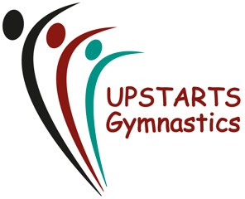

CODE OF CONDUCT for GYMNASTS
- All gymnasts should respect their fellow gymnastic club members.
- All gymnasts are to train in suitable Gymnastic attire – for Girls, Leotard with/without shorts/leggings, for Boys, Leotard and shorts. No baggy clothing or strappy tops, no ‘hoodies’ during training. (pre-schoolers do not need leotards)
- Gymnasts are NOT allowed to wear any jewellery during training sessions, displays or competitive events.
- Hair – All gymnasts with long hair are required to have hair suitably tied back during each training session (this includes all long fringes).
- Gymnasts are to behave in an upstanding manner and bullying & swearing will not be tolerated at any time.
- Any illness or injuries should be brought to the attention of your coach.
- Gymnasts are encouraged to arrive on time for each lesson.
- All equipment and apparatus should be treated with respect.
- Gymnasts should not leave the gymnasium at the end of their session until collected by their parent/guardian.
- Gymnasts are to train barefoot unless there is a medical reason prohibiting them from doing so. (Coaches are to be made aware of this before warm up).
- Gymnasts should never train or work on equipment without a qualified coach present.
- Upstarts Gymnastics Club cannot be held responsible for lost or stolen items. Ensure items of clothing are named.
- Gymnasts should respect their coaches and any decisions made.
- Gymnasts can approach the Welfare officer if they have any concerns or wish to speak confidentially to a coach.
- Gymnasts must not eat or chew gum during any session.
- Gymnasts – if you do not follow the Upstarts code of conduct, your parents may be contacted and your membership suspended or revoked.
We thank you for your support

SIGNED____________________________________________DATE___________
If gymnast under the age of 16yrs, parent must sign on their behalf

