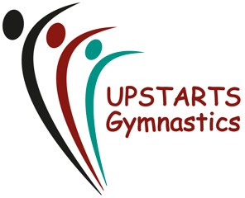

Progression to Development or Competition Pathways

Development and Competitive Squad participation is by invitation only. However, you may be wondering how your child would get into a development squad.
At Upstarts Gymnastics Club children with aptitude for competitive development are identified within the recreational classes. These classes are our day to day, one hour to ninety-minute sessions, where participation activities are aimed at developing strength, flexibility and foundation skills.
Children showing an aptitude for progressing their skills gymnastics beyond recreational activities will be developed within the sessions and if improvement continues, may be invited to work within development sessions to supplement their learning or attend trial sessions with a view to joining a development squad.
Remaining in the development squad is dependent on the individual’s progress physically, emotionally and mentally; at all times the child’s wellbeing is put first. From the development squad a young gymnast will be progressed to a group that best suits them and their current development, this may be a higher recreational squad, another level development squad, or a competition squad.
In some cases, gymnasts transfer from other disciplines, or another club. In these circumstances, please get in touch by email and we would offer a trial to evaluate the gymnasts and signpost to the best group for them.

Competitive Squads
County, Juniors, Seniors

Recreational Classes
Foundation, Intermediate and Advanced

Development Group

