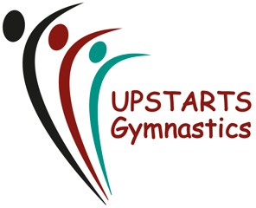
CODE OF CONDUCT for PARENTS
- Parents should encourage their child to learn the rules and participate within them.
- Ensure your child is fit to take part in gymnastics activity and inform coaches if your child has any illness
- Ensure your child is appropriately dressed for their class (also see Gymnast Code of conduct for suitable attire).
- Due to the nature of physical activity taking place within each lesson, make sure your child has a drink with them in a closed top drinks bottle – NO FIZZY.
- Please arrive and collect your child promptly at the beginning and end of each lesson. (Parents are not invited into the gym area, but can view from the upstairs social/waiting area).
- Parents are to ensure that all gymnasts have used the bathroom before each lesson to minimise class disruption.
- Parents are expected to ensure that all payments are made on time,
- Ensure your child does not bring any valuable items to their lessons.
- Ensure any changes of contact details are kept up to date in writing.
- Parents should discuss any worries or complaints at a convenient time (Beginning/End of sessions) or via Email or Telephone.
- Parents should promote good sportsmanship at all times and support your child’s involvement.
- Parents are invited to attend any display events or competitions.
- Respond to any information from the club quickly and familiarise yourself with any club information.
- Whilst in the gymnasium, every effort will be made by the coaches to ensure the safety of each gymnast therefore, we would ask you to respect the coaching techniques and decisions made by the coaching team.
- Abusive, intimidating and demeaning behaviour from any gymnast, parent, guardian or visiting family member will not be tolerated and will be dealt with accordingly.

We thank you for your support

SIGNED____________________________________________DATE___________

A copy of this will be emailed to you for your own records.

